**Over The Wire**

## Level 10 to Level 11

**Step 1: SSH Login**

**Password:** **FGUW5ilLVJrxX9kMYMmlN4MgbpfMiqey**

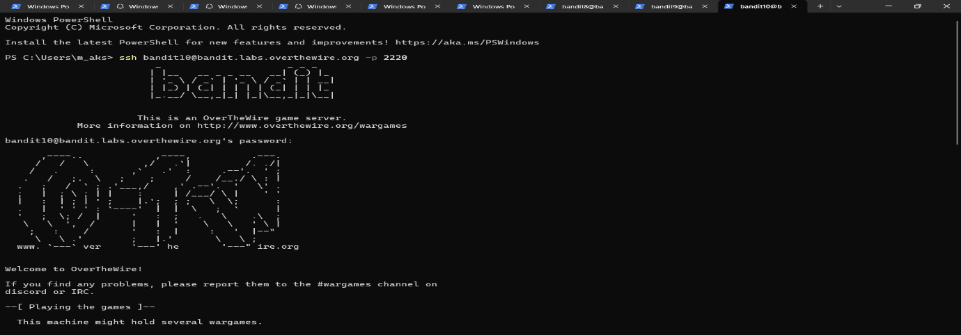

**Step 2: Decode Base64**

**base64 -d data.txt**

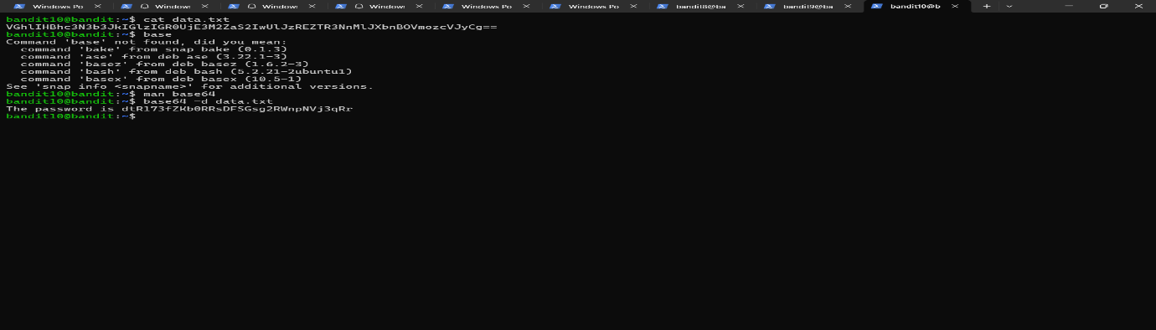

**Password**: dtR173fZKb0RRsDFSGsg2RWnpNVj3qRr